Mapy
Wcześniej uruchom skrypt z pod tabeli

1 | 
2 | 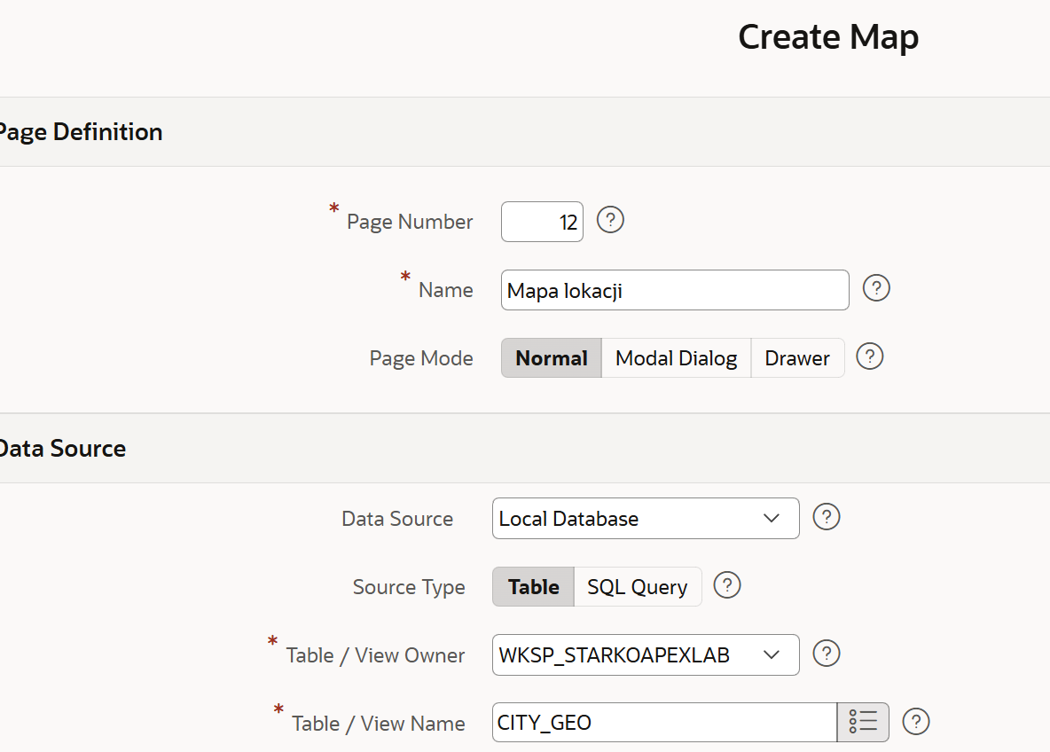
3 | 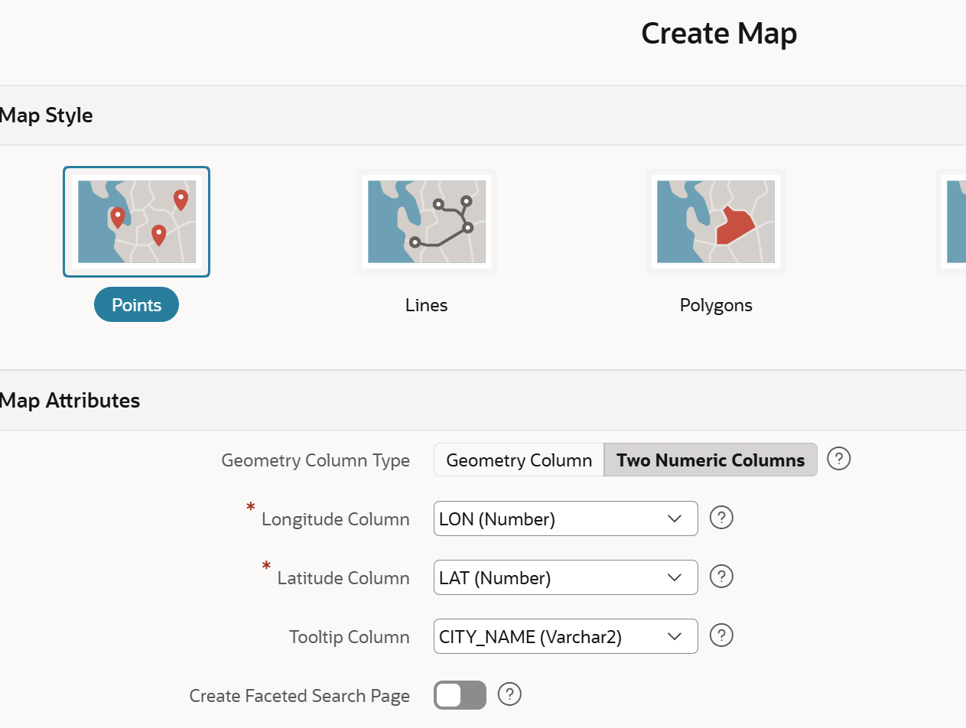
4 | Efekt  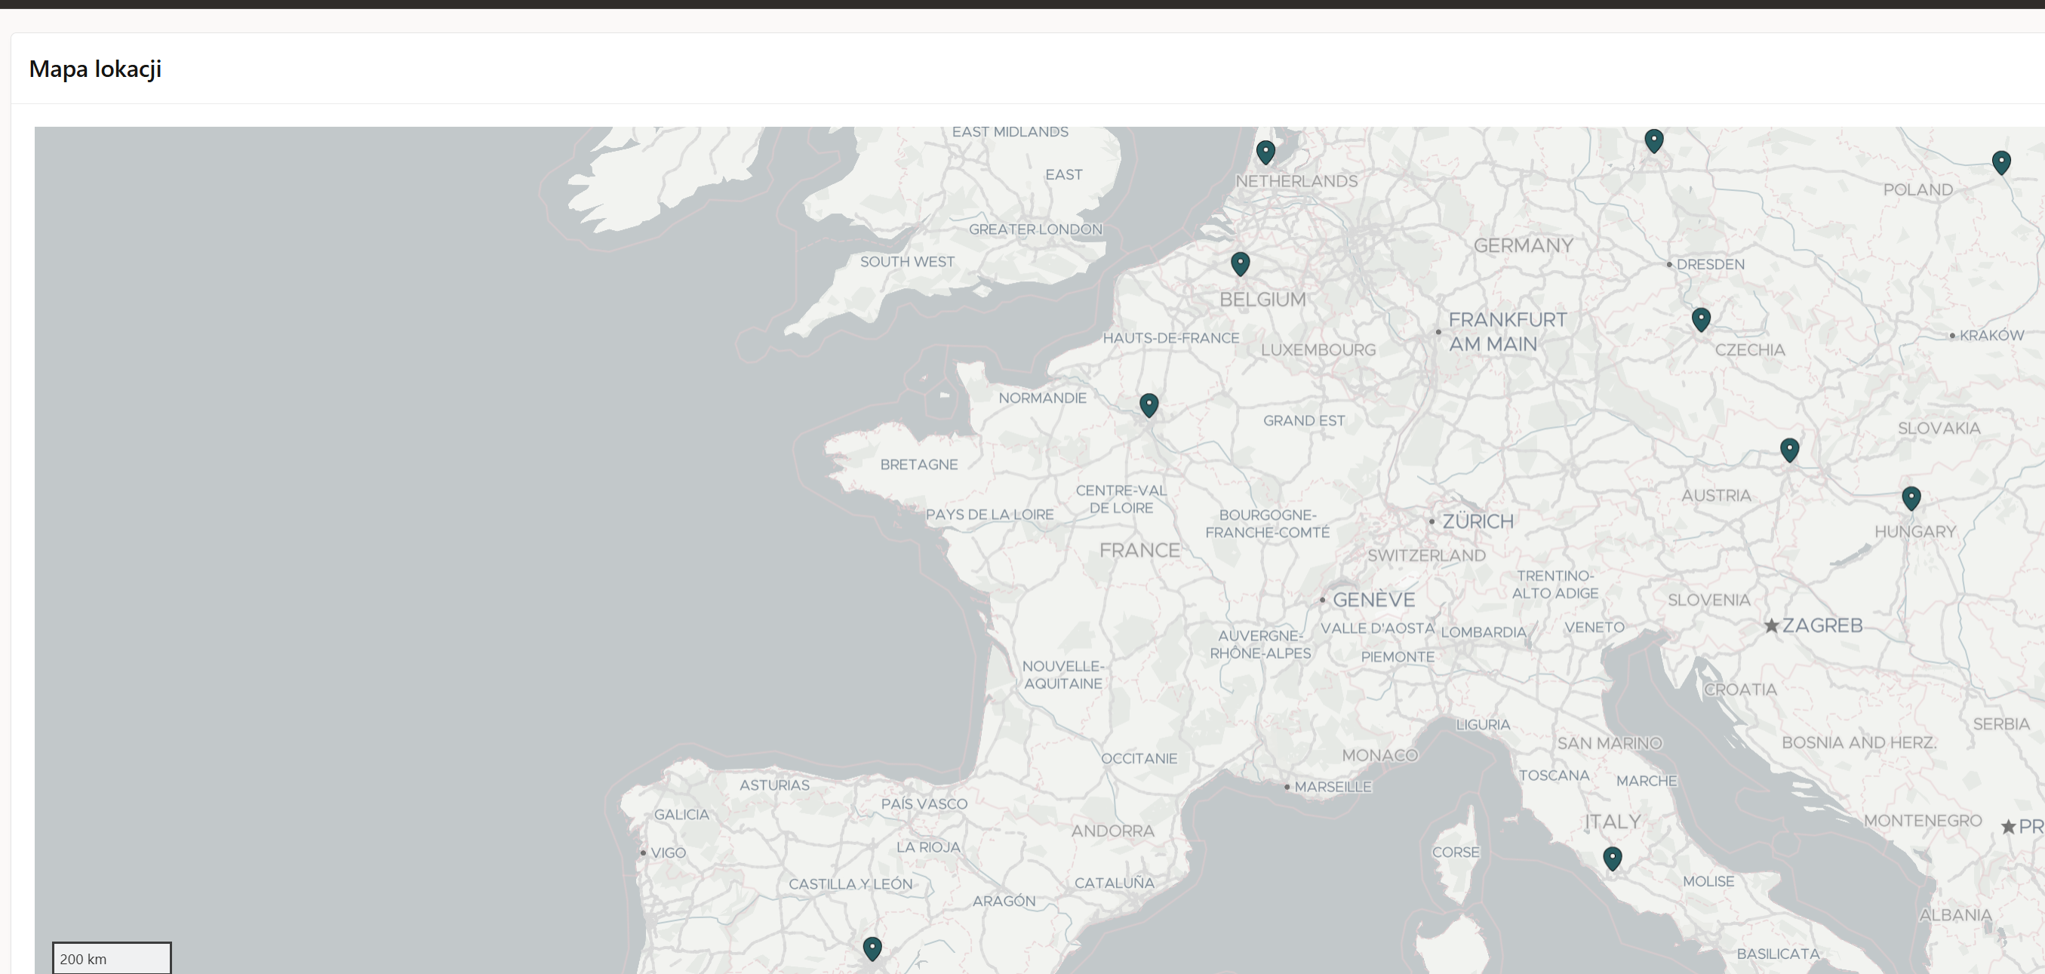

-- ============================================================
-- Definicja tabeli CITY_GEO
-- ============================================================
CREATE TABLE CITY_GEO (
ID NUMBER(10) NOT NULL,
CITY_NAME VARCHAR2(100) NOT NULL,
COUNTRY VARCHAR2(100) NOT NULL,
LON NUMBER(10, 6) NOT NULL, -- długość geograficzna (longitude)
LAT NUMBER(10, 6) NOT NULL, -- szerokość geograficzna (latitude)
CONSTRAINT PK_CITY_GEO PRIMARY KEY (ID)
);

-- ============================================================
-- Inserty do tabeli CITY_GEO
-- ============================================================
INSERT INTO CITY_GEO (ID, CITY_NAME, COUNTRY, LON, LAT) VALUES (1, 'Warszawa', 'Polska', 21.012200, 52.229700);
INSERT INTO CITY_GEO (ID, CITY_NAME, COUNTRY, LON, LAT) VALUES (2, 'Berlin', 'Niemcy', 13.405000, 52.520000);
INSERT INTO CITY_GEO (ID, CITY_NAME, COUNTRY, LON, LAT) VALUES (3, 'Paryż', 'Francja', 2.352200, 48.856600);
INSERT INTO CITY_GEO (ID, CITY_NAME, COUNTRY, LON, LAT) VALUES (4, 'Rzym', 'Włochy', 12.496400, 41.902800);
INSERT INTO CITY_GEO (ID, CITY_NAME, COUNTRY, LON, LAT) VALUES (5, Barcelona, 'Hiszpania', 41.3851, 2.1734);
INSERT INTO CITY_GEO (ID, CITY_NAME, COUNTRY, LON, LAT) VALUES (6, 'Wiedeń', 'Austria', 16.373800, 48.208200);
INSERT INTO CITY_GEO (ID, CITY_NAME, COUNTRY, LON, LAT) VALUES (7, 'Praga', 'Czechy', 14.437800, 50.075500);
INSERT INTO CITY_GEO (ID, CITY_NAME, COUNTRY, LON, LAT) VALUES (8, 'Budapeszt', 'Węgry', 19.040200, 47.497900);
INSERT INTO CITY_GEO (ID, CITY_NAME, COUNTRY, LON, LAT) VALUES (9, 'Amsterdam', 'Holandia', 4.904100, 52.367600);
INSERT INTO CITY_GEO (ID, CITY_NAME, COUNTRY, LON, LAT) VALUES (10, 'Bruksela', 'Belgia', 4.351700, 50.850300);

COMMIT;

